|  |
| --- |
| **PROJECT CREATION && MODIFICATION**  ADVANCED PROGRAMMING TECHNIQUES |

**Action:** Modification*.*

Lógica base casi terminada, pero necesita reorganizarse. GUI implementada.

**Project:** OOP Chess

**Date:** 28/11/2022

**Description:**

El objetivo es hacer un ajedrez utilizando programación orientada a objetos y técnicas modernas para hacer una interfaz “*user-friendly*”.

**Resources:** Inspiración de código e ideas de diseño y estructura de:

<https://akshay-iyangar.github.io/system-design/grokking-ood/examples/java/chess.html>

<https://www.geeksforgeeks.org/design-a-chess-game/>

<https://www.chessprogramming.org/Main_Page>

<https://medium.com/double-pointer/system-design-interview-a-two-player-online-chess-game-4a150ad8ea78>

<https://www.youtube.com/watch?v=xaJxBsxqkyM&ab_channel=GerardTaylor>

<https://stackoverflow.com/questions/21077322/create-a-chess-board-with-jpanel>

https://refactoring.guru/

**Other:**

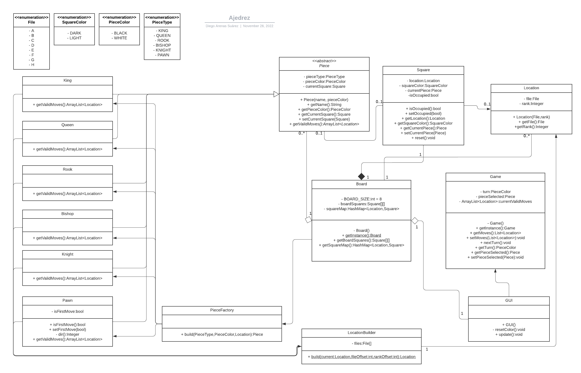**UML diagram:**